

SEMESTER 1 EXAMINATION 2011/2012

Data Structures and Algorithms II

COMP2002F

Mr J. Dunnion
Dr. R. Collier*

Time allowed: 2 hours

Instructions for candidates

Answer any 2 questions

1. Answer parts (a) to (e). 50 marks in total
- What is a tree? List the operations that are typically associated with this Abstract Data Type. Provide a brief description of each operation.
(13 marks).

Definition (2 marks)
A Tree is a hierarchical ADT where data is related in terms of parent-child relationships.
  - Each element (node) in the tree has at most 1 parent.
  - Each element (node) may have 0 or more children.
  - Each tree will include exactly one element (node), known as the root, which has no parent.

Operations (11 marks):
  - root() returns the Position for the root
  - parent(p) returns the Position of p’s parent
  - children(p) returns an Iterator of the Positions of p’s children
  - isInternal(p) does p have children?
  - isExternal(p) is p a leaf?
  - isRoot(p) is p==root()?
  - size() number of nodes
  - isEmpty() tests whether or not the tree is empty
  - iterator() returns an Iterator of every element in the tree
  - positions() returns an Iterator of every Position in the tree
  - replace(p, e) replaces the element at Position p with e

- One application of binary trees is a heap. Heaps make use of two key properties: the order and structural completeness properties. Give definitions for each of these properties.
- marks).
Order Property: key(parent) ≤ key(child)
Structural “Completeness” Property: all levels are full, except the bottom, which is “left-filled”

- Describe the steps by which items are removed from a heap. Illustrate your answer by removing an item from the following heap.
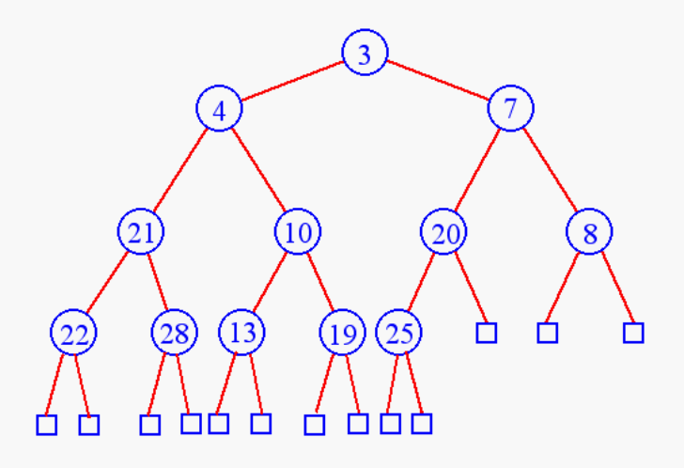
Removing from a Heap (8 marks + 3 marks for solving the problem):
  - Remove the root node (this is the current min entry).
  - Replace this node with the last item in the heap, node L.
  - Perform a Downheap to re-establish the “ordering property”. This involves checking whether L is less that its children. If it is not, then L is swapped with the smaller of the two children, and downheap is performed again on L in its new position.
  - Update the “last” reference. Need to do an inverse pre-order traversal (I.e. goto the node that is before the last node in a pre-order traversal). If there is no previous node, then find the last node on the next level up.
(11 marks).

- Boyer-Moore is a pattern matching algorithm that can be used to locate the first occurrence of a pattern in a text. Explain how the last occurrence function works, and give the pseudo code for the Boyer-Moore algorithm. Illustrate your answer by showing how Boyer-Moore locates the pattern “abacab” in the text “abacaabadcabacabaabb”.
(14 marks)

Last-Occurrence Function (3 marks):
- Boyer-Moore’s algorithm preprocesses the pattern P and the alphabet Σ to build the last-occurrence function L mapping Σ to integers where L(c) is defined as:
  - The largest index i such that P[i] = c or
  - -1 if no such index exists

Algorithm (6 marks):
Algorithm BoyerMooreMatch(T, P, Σ)
Input: text T of size n and pattern P of size m.
Output: starting index of a substring of T equal to P or -1 if no such substring exists.
L ¬ lastOccurrenceMap (P, Σ)
i ¬ m-1
j ¬ m-1
do
if T[i] = P[j] then
if j=0 then return i
else
i ¬ i - 1
j ¬ j - 1
else
l ¬ lastOccurrence(L, T[i])
i ¬ i + m – min(j, 1+l)
j ¬ m - 1
until i > n - 1
return -1

Example (5 marks):
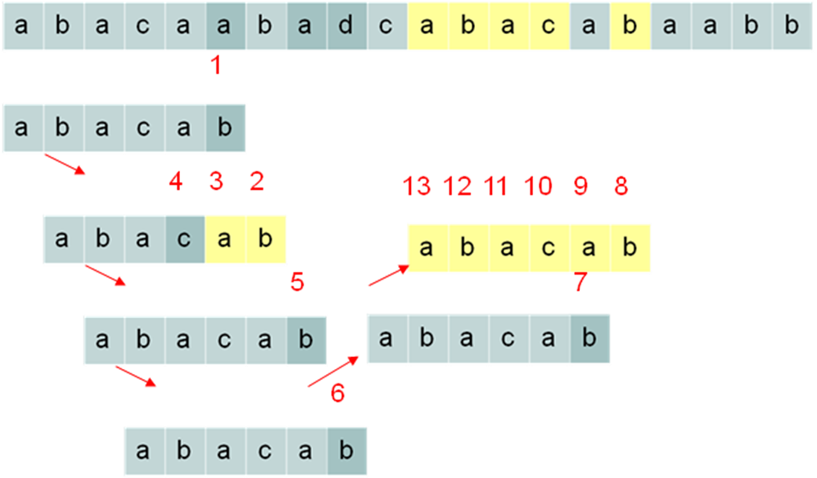
c | a | b | c | d
L(c) | 4 | 5 | 3 | -1

- What is a graph? Give definitions of the following graph concepts: adjacent vertices, path and cycles.

Graph Definition (2 marks + 2 marks per concept):
A graph is a pair (V, E), where
  - V is a set of nodes, called vertices
  - E is a collection of pairs of vertices, called edges
  - Vertices and edges are positions and store elements

Adjacent Vertices: The set of vertices at the opposite end of the incident edges of a vertex.
Path: a sequence of alternating vertices and edges that begins and ends with a vertex, and where each edge is preceded and followed by its endpoints.
Cycle: a path that starts and finishes at the same vertex
(8 marks)

2. Answer parts (a) to (d). 50 marks in total

- What is a binary search tree? Illustrate your answer by drawing the binary search tree that would be obtained after the following items has been inserted in the given order:

13, 7, 19, 6, 14, 4, 15, 3, 17, 2
(14 marks).
Definition (4 marks):

A binary search tree is a tree that satisfies the following properties:

Let u, v, and w be three nodes such that u is in the left subtree of v and w is in the right subtree of v. We have:

key(u) ≤ key(v) ≤ key(w)

Solution (10 marks)

- What is an AVL Tree? Explain any properties that an AVL tree must satisfy.
(4 marks)
- AVL trees are an example of a self-balancing binary search tree.
  - AVL trees must satisfy the height-balance property:
  - For every internal node v of T, the heights of the children of v can differ by at most 1.
  - AVL trees have expected performance O(log n).

- Describe how a node is inserted into an AVL Tree. Include in your answer a discussion of how the tree is restructured. Illustrate your answer by constructing the AVL Tree that is generated by inserting the following values:

13, 7, 19, 6, 14, 4, 15, 3, 17, 2

(20 marks)

Insertion (10 marks):
- AVL trees are binary trees.
  - Insertion is the same as in a binary search tree.
  - We simply locate the relevant external node and expand it.
  - Because AVL trees are balanced:
  - The expected performance of this operation is O(log n)

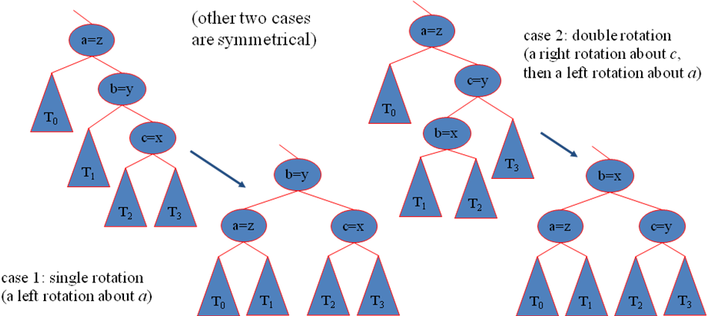

Example (10 marks): 1 mark per correct insertion (restructurings on 4, 15, and 2.

- Prove that the height of an AVL tree is O(log n)
(12 marks).
Proof:
Let us bound n(h): the minimum number of internal nodes of an AVL tree of height h.

By inspection of example AVL trees, we can easily see that n(1) = 1 and n(2) = 2.

For h > 2, an AVL tree of height h contains the root node, one AVL subtree of height h-1 and another of height h-2. That is:

n(h) = 1 + n(h-1) + n(h-2)

Because our equation for n is a strictly increasing function of h, we also know that:

n(h-1) > n(h-2)

Hence, by replacing n(h-1) with n(h-2) we get:

n(h) > 2 . n(h-2)

And it then follows that:

n(h) > 4n(h-4),
n(h) > 8n(h-6),
…,
n(h) > 2i. n(h-2i)

But, we can solve this for a base case - we know the values for n(1) and n(2).

So, lets consider the case of n(2), hence we assume that:

h – 2i = 2

This, in turn, means that:

i = (h/2) – 1

Plugging our value of i into the inequality for n(h) gives us:

n(h) > 2(h/2)-1. n (h – 2 . ( (h/2) – 1 ) )
n(h) > 2(h/2)-1. n (h – 2 (h/2) + 2 )
n(h) > 2 (h/2)

Taking logarithms:
log n(h) > log ( 2 (h/2) )
log n(h) > h/2
h < 2. log n(h)

Thus the height of an AVL tree is O(log n)

3. Answer parts (a) to (d). 50 marks in total
- Merge Sort and Quick Sort are examples of sorting algorithms that are based upon an algorithmic design pattern called divide-and-conquer. Describe this design pattern, and use it to outline the main steps involved in both the Merge Sort and Quick Sort algorithms.
(10 marks)

Divide-and conquer
General algorithm design paradigm:
• Divide: divide the input data S in two disjoint subsets S1 and S2
• Recur: solve the subproblems associated with S1 and S2
• Conquer: combine the solutions for S1 and S2 into a solution for S

The base case for the recursive step is a sub-problem of size 0 or 1
(4 marks)

Merge Sort:
Take an input sequence S with n elements consists of three steps:
• Divide: partition S into two sequences S1 and S2 of about n/2 elements each
• Recur: recursively sort S1 and S2
• Conquer: merge S1 and S2 into a unique sorted sequence
(3 marks)

Quick-sort:
Randomized sorting algorithm:
• Divide: pick a random element x (called pivot) and partition S into
o L elements less than x
o E elements equal x
o G elements greater than x
• Recur: sort L and G
• Conquer: join L, E and G
(3 marks)

- The key operation of the Merge Sort algorithm is the merge operation. Give the pseudo code for both this operation and the overall merge sort algorithm. Use merge sort to sort the following sequence of numbers:
15, 7, 4, 19, 12, 8, 6, 24
(18 marks)

Algorithm merge(A, B)
Input sequences A and B with n/2 elements each
Output sorted sequence of A ∪ B
S ← empty sequence
while ¬A.isEmpty() & ¬B.isEmpty()
if A.first().element() < B.first().element()
S.insertLast(A.remove(A.first()))
else
S.insertLast(B.remove(B.first()))
while ¬A.isEmpty() S.insertLast(A.remove(A.first()))
while ¬B.isEmpty() S.insertLast(B.remove(B.first()))
return S
(6 marks)

Algorithm mergeSort(S, C)
Input sequence S with n elements, comparator C
Output sequence S sorted according to C
if S.size() > 1
(S1, S2) ← partition(S, n/2)
mergeSort(S1, C)
mergeSort(S2, C)
S ← merge(S1, S2)
(4 marks)

- What is the running time of Merge Sort? Explain how this value is calculated.
(6 marks)
- The height h of the merge-sort tree is O(log n)
  - at each recursive call we divide the sequence in half
- The overall amount or work done at the nodes of depth i is O(n)
  - we partition and merge 2^{i} sequences of size n/2^{i}
  - we make 2^{i+1} recursive calls
- Thus, the total running time of merge-sort is O(n log n)

- How does Radix Sort work? Explain how you would sort strings of different lengths, and use this to sort the following strings:

cat, door, to, a, date, tar

NOTE: Here, you can assume the alphabet for the sort is: {a, c, d, e, o, r, t}

(16 marks)
Description (4 marks)
- Radix: the base of a number system or logarithm.
- Uses a bucket sort algorithm so is also stable
  - Radix sort is a multiple pass distribution sort.
- It distributes each item to a bucket according to part of the item's key.
- After each pass, items are collected from the buckets, keeping the items in order, then redistributed according to the next most significant part of the key.
  - For numbers, it sorts keys digit-by-digit, for strings it sorts character-by-character.
- Assumes that all elements have the same number of digits

Extension (4 marks):
Introduce a padding character to represent (no character), pad all the strings with the padding character so they are all the same length (padding must go to the right of the string), and include this additional character as a bucket.

Example (8 marks) – 2 marks per correct bucket sort

